

STATE OF INDIANA

Request for Proposal 20-014

Addendum #2

INDIANA DEPARTMENT OF ADMINISTRATION

On Behalf Of
INDIANA FAMILY & SOCIAL SERVICES ADMINISTRATION
DIVISION OF MENTAL HEALTH AND ADDICTION

Solicitation For:
NEURODIAGNOSTIC INSTITUTE ADOLESCENT AUTISM SPECTRUM DISORDER (ASD) AND DEVELOPMENTAL DISABILITIES DISORDER UNIT MANAGEMENT

Response Due Date: July 11, 2019 @ 3:00 PM EST

Mark Hempel
Indiana Department of Administration
Procurement Division
402 W. Washington St., Room W468
Indianapolis, Indiana 46204
Summary of Changes
Deletions are indicated via strikethrough and additions have been made in red font.

The following edits have been made to the RFP Document:

- On the title page,

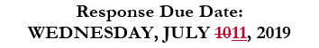

- In section 1.8, DUE DATE FOR PROPOSALS

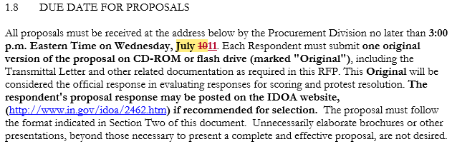

- In Section 1.24, SUMMARY OF MILESTONES

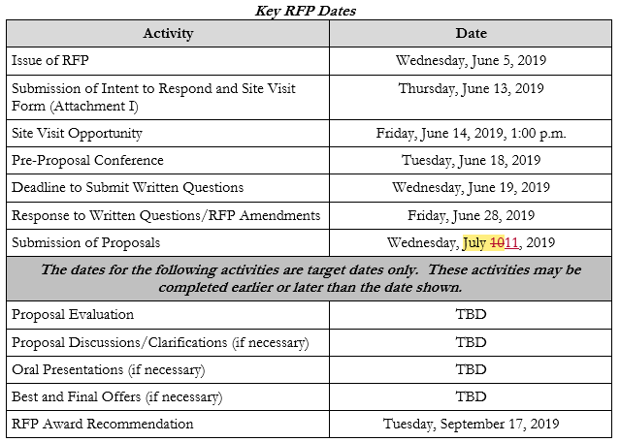

- An unlocked version of the Cost Proposal has also been posted to the solicitation site.

